***Spring Boot CRUD Operations***

CRUD- Create, Read, Update, Delete; 4 basic functions of persistence storage.

CRUD operations allow view, search and modify info through computer based forms and reports. CRUD is data oriented.

HTTP Action Verbs:

Post: New resource creation

Get: Resource reading

Put: Resource updation

Delete: Resource deletion

Standard CRUD Operation:

Create: Performs INSERT statement to create new record

Read: Based on the input parameter, reads table records

Update: Based on the input parameter, executes UPDATE statement on table

Delete: Based on the input parameter, deletes specific row in table

Through CRUD, user can change info online also.

Most efficient way to execute CRUD: Create a set of stored procedures in SQL to execute operations.

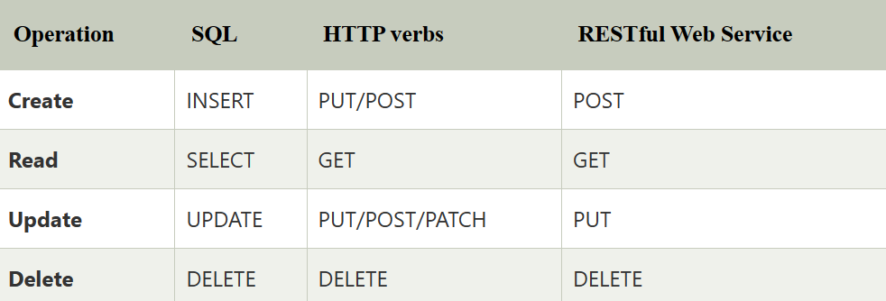

Spring Boot Crud Repository

Interface of Spring Boot called CrudRepository, it contains methods for CRUD operations. Its defined in the package org.springframework.data.repository. Extends the interface Repository. If we want to use this interface, we have to create and interface and extend this interface.

Syntax:

**public** **interface** CrudRepository<T,ID> **extends** Repository<T,ID>

where

T- domain type that the rep manages

ID- type of the id of the entity that rep manages

Spring Boot Jpa Repository

Provides JPA related methods such as flushing, persistence context and delete record in a batch. Defined in the package org.springframework.data.jpa.repository. This extends CrudRepository and PagingAndSortingRepository.

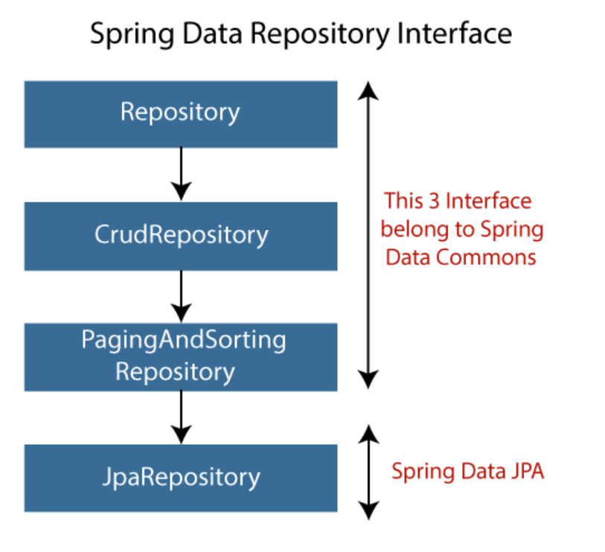

These interfaces allow Spring to find the repository interface and create proxy pbjects for that. We can also define custom methods.

CrudRep is different from JpaRep, below are the differences.

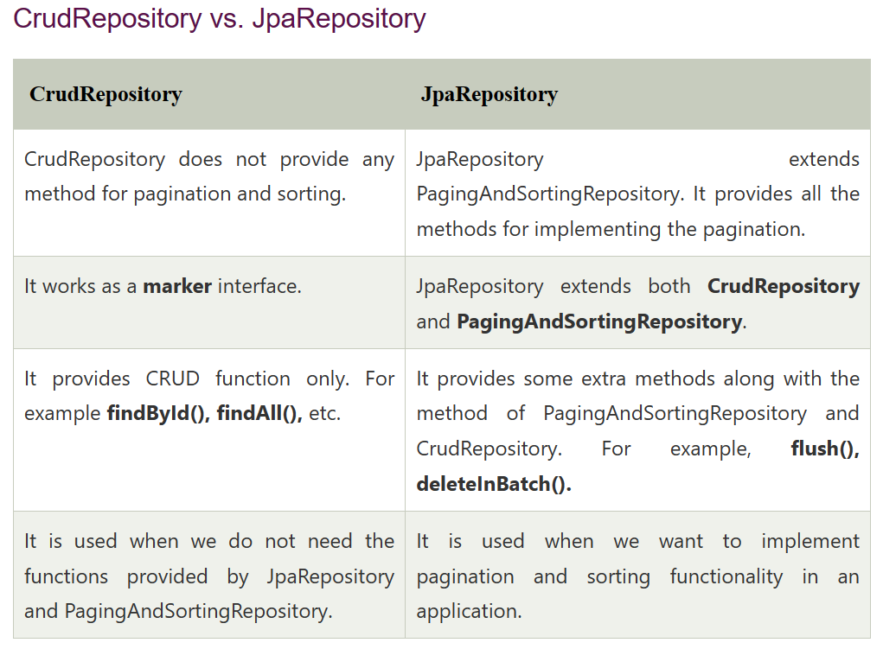

These are the four fundamental activities we carry out on persistence storage, and their acronym CRUD stands for Create, Read/Retrieve, Update, and Delete. Data-oriented CRUD employs common HTTP techniques. A few HTTP methods function as CRUD processes, and it is important to note that they are crucial from the standpoint of programming development. They also help us understand web development better and support us while working with databases. The following are examples of standard CRUD Operations:

POST: Creates a new resource  
GET: Reads/Retrieve a resource  
PUT: Updates an existing resource  
DELETE: Deletes a resource

In order to illustrate CRUD operations over the Student Management program, let us consider we are creating a MENU DRIVER program that will have a student list. The list will hold the student object that contains student details. Your menu should have 4 basic operations like Add, Search, Remove, and Show details of the student.

First we create a student record Management system that performs operations like Insert Student Record

Delete Student Record

Show and search student record

Then a student record linked list is made then a student record management code is done which contains the the functions that does the operations and then theres record that stores the data.